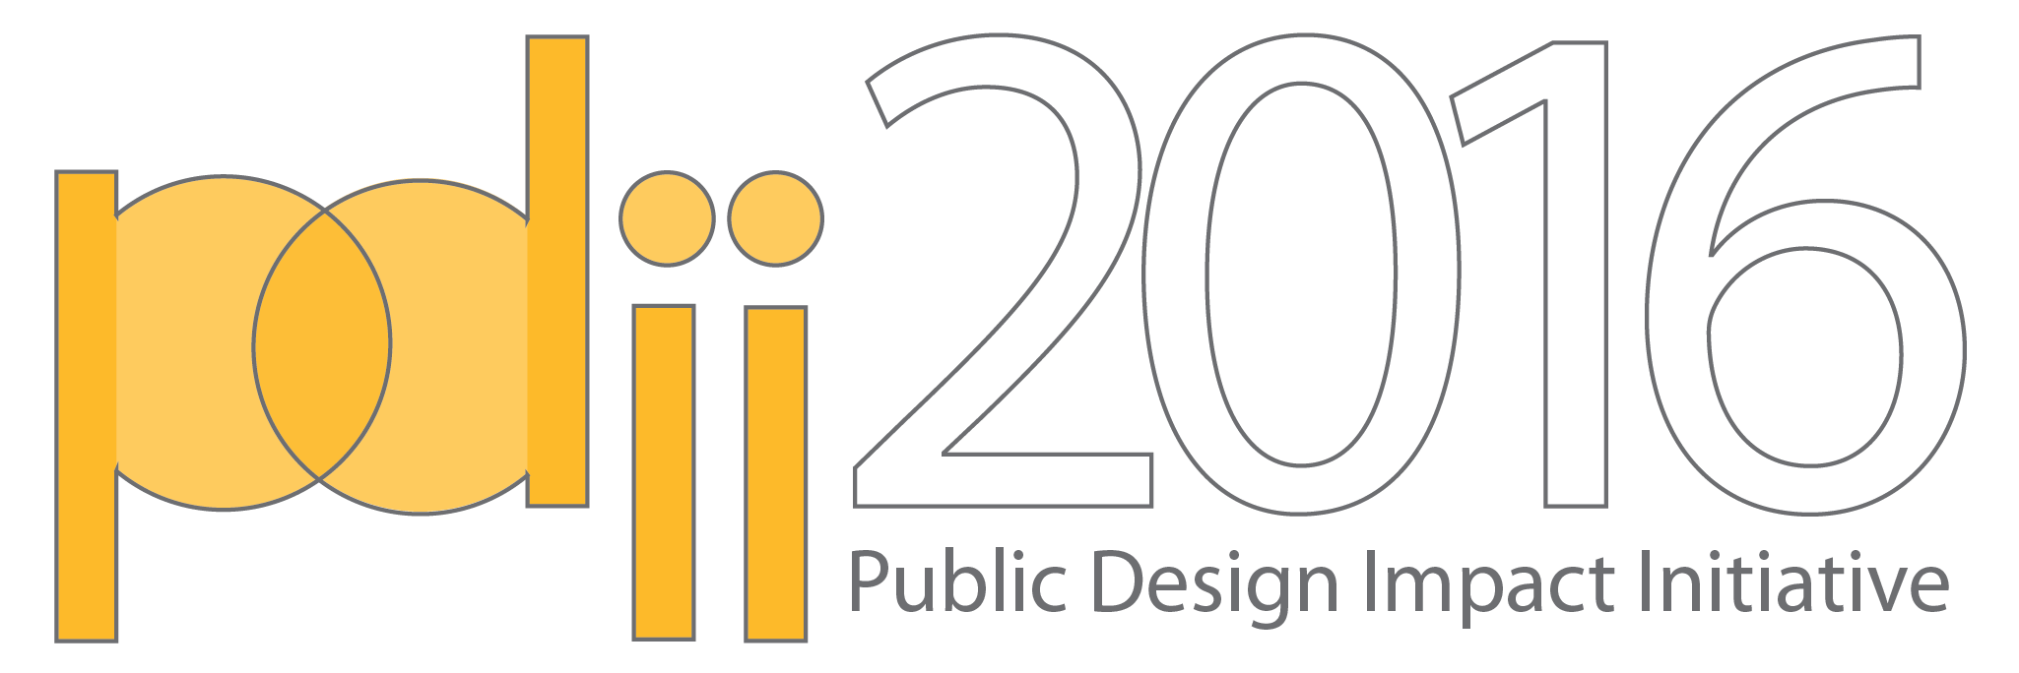
Many social issues can be successfully addressed through thoughtful design and planning interventions. The Public Design Impact Initiative (PDII) provides opportunities for partnerships between design professionals and community-based organizations who do not usually have access to design services. buildingcommunityWORKSHOP ([bc]) has found that the partnerships between designers and community-based organizations are mutually beneficial, building the knowledge and experience of both to better serve others.

With that in mind, [bc] is inviting community groups and organizations to submit design project proposals to be matched with local design professionals. This year, as part of a collaborative effort to extend equity in design to rural colonia areas, [bc] is seeking proposals from nonprofit organizations and community based groups in the Rio Grande Valley.

Assistance with creating & submitting a
project proposal, will be available on
Thursday, May 12th from 6:00 - 7:30pm
at 609 E. 11th St., Brownsville, TX, 78520.

buildingcommunityWORKSHOP ([bc]) is inviting nonprofit organizations and community-based groups in the Rio Grande Valley to submit project proposals to receive pro-bono architecture, planning and/or design services.

Up to 2 proposals will be accepted for the 2016 Request for Proposals. Recipients will receive pro-bono professional design/planning services grant from [bc] and local Design Partners to complete the proposed project.

Each project will establish an individual schedule. Though project schedules will vary based on the scope of work, all projects should be able to be completed within 4-6 months and will follow these phases:
- DISCOVERY - in-depth engagement between the design team and the community. This phase will create opportunities to collect and share information about the project and the neighborhood; and is essential to creating a product that is well-informed.
- DESIGN - creation of a series of solutions to address the design problem outlined in the project proposal. This phase includes continued communication between the design team, nonprofit, and community for feedback and refinement.
- PLAN - a plan of action outlining the schedule and products of the project is created and agreed upon by the nonprofit/community group and design team.
- IMPLEMENTATION - production of the agreed on design product by the design team and nonprofit/community group.

Submitting a Project Proposal
The deadline to submit a completed Project Proposal is May 30th, 2016. The Project Proposal Form (the last page of this document) may be submitted through mail, email, or using the online form. You can find an editable, print-friendly version of the Project Proposal Form and more information at bcworkshop.org/pdii2016.

To submit via online form:
Use this link - bcworkshop.typeform.com/to/De5vby

To submit via email:
Send your completed Project Proposal as a PDF document to elaine@bcworkshop.org. Include “PDII Project Proposal” in the subject line.

To submit a project proposal via mail:
Send a hardcopy of your Project Proposal to the address below. You will be notified when your submission has been received using the email address provided in Part I of your Project Proposal. Mailed copies must be received by Monday, May 30th, 2016.
Attn: Public Design Impact Initiative
bcWORKSHOP
609 E. 11th St.
Brownsville, TX 78520

Questions & comments related to the Public Design Impact Initiative should be directed to Elaine Morales, at
elaine@bcworkshop.org or 956.443.2211

Eligibility
All RGV-based community and nonprofit groups (including nonprofit organizations, neighborhood associations, school PTA groups, etc.) are invited to submit Project Proposals. Applicants must be made up of a group of three or more individuals and should be both located within the RGV area. Proposed projects must also be located in the RGV and address issues related to colonias.

Proposals are welcome from all not-for-profit groups, from large and established nonprofit organizations to small/less formal community groups, regardless of the scale or scope of work.

Selection Criteria
Once all proposals are received they will be reviewed by a jury that includes representatives of the local, Rio Grande Valley nonprofit and design community. Selected project proposals will be notified in June of 2016. At that time, selected applicants will be matched with local design expertise to pursue the selected project proposals.

The jury will select project proposals based on the following criteria:
- A clearly defined scope of work that can feasibly be completed in a 4-6 month timeframe.
- The level of urgency of the project and its associated risks of the project proposal.
- The timeliness and relevance of the issue(s) being addressed in the project proposal.
- Apparent readiness of the applicant nonprofit / community group to begin work.
- The likelihood of the applicant, the design partner(s), and the community will benefit from the work.

Proposals must be for a specific project that addresses a stated issue/need that exists in the RGV. Selection of projects will be based on greatest benefit to organizations working in colonias, and to colonia residents and communities.

Examples of Services Provided
PDII seeks to connect nonprofit and community groups with design-related professions, including: Architecture, Interior Design, Urban Design, Planning, Landscape Architecture, Graphic Design, Creative Placemaking, Construction, Media, and Visual & Performing Arts.

Services provided include, but are not limited to the following:
- Building & Landscape Design: accessibility surveys, adaptive reuse, as-designed & as-constructed drawings, commercial buildings, community/institutional facilities, ecological restoration, green infrastructure, historic restoration/preservation, industrial building design, interior design, LEED certification, mixed-use development, park design, and residential buildings.
- Visual Art & Communications: advocacy campaigns, audio recordings, brand development, capital campaigns, coding, digital communications, filming, photography, print-based publications, public art installations, public performance, wayfinding & signage, web-based design.
- Planning, Research & Public Policy: asset mapping, contextual analysis, data collection, data analysis, feasibility studies, historic research, mapping, public space assessment, planning, public policy, and strategic analysis.

These examples are included to provide an idea of the types of services we aim to provide, but PDII is open to proposals and ideas that push the boundaries of design and planning.
Public Design Impact Initiative 2016 - Project Proposal Form
buildingcommunityWORKSHOP is currently accepting Project Proposals in the Rio Grande Valley. Project Proposals must include the information and supporting documents requested in Parts 1-4 below.

You can submit your Project Proposal online at bcworkshop.typeform.com/to/De5vby via email as a pdf file to elaine@bcworkshop.org, or via mail to 609 East 11th Street, Brownsville, TX 78520. You can find an editable, print friendly version of the Project Proposal Form, plus more information at bcworkshop.org/pdii2016. The deadline to complete and submit this form is Monday, May 30th, 2016.

Part 1: CONTACT INFORMATION
Your name:
Name of Organization/Group:
Address, City, State, Zip:
Website (Optional.):
Email:
Phone Number:

Part 2: PROJECT PROPOSAL
Describe the project you would like to propose. (200 word maximum)

What need does this project address in your community? (150 word maximum)

How much will this project cost? (If the proposed project has an existing budget, please list it here. When creating a budget, consider the total cost of materials, labor, and/or equipment the project might require.)

What will this project achieve? (Optional. 150 word maximum)

Are there any deadlines associated with this project? (Optional. If yes, please list the date or dates)

How will you determine if the project is a success? (Optional. 150 word maximum)

Part 3: ORGANIZATION/GROUP PROFILE
What does your organization/group do? (150 word maximum)

Describe the geographic area in which you work. (150 word maximum)

What year was your organization/group established?

What are some major accomplishments/milestones reached in the previous 3 years? (Optional. 150 word maximum)

How many staff does your organization/group employ?

How many members does your organization have? (Optional.)

What is your Annual Operating Budget? (Optional.)

Part 4: LETTERS OF SUPPORT OR SAMPLES OF WORK
To complete the application, submit the following documents: 2 Letters of Support OR 2 Samples of Work, in pdf format. These documents are to illustrate that you are actively working to achieve your organization or group goals.

A Letter of Support must be written by an individual outside of the organization or group. A Sample of Work must show examples of completed projects or ongoing programs run by the organization or group submitting the Project Proposal. We encourage including both images and written descriptions of the work.

Both documents should be formatted on 8.5 x 11 (letter) paper, cannot exceed a total of five pages in length. If you are submitting your Project Proposal online or by email, these documents should be submitted as pdf files, and should not exceed 10MB.

